**Module 1 Critical Thinking Assignment: Bank Account Superclass & Inheritance**

Andrew Barnes

Colorado State University Global

CSC372-1

Dr. Reginald Haseltine

12/17/2023

**BankAccount Class**

The *BankAccount* class is a superclass with select data and operations representing a bank account. The fields included in this class are the account owner’s first name, last name, account ID, and account balance. Within the class are methods for depositing and withdrawing funds with an *amount* parameter passed into these methods, along with an account summary method. All the fields in this class have getters and setters except for the balance, which only has a getter since every account starts at 0, and the deposit and withdrawal methods denote the change in balance.

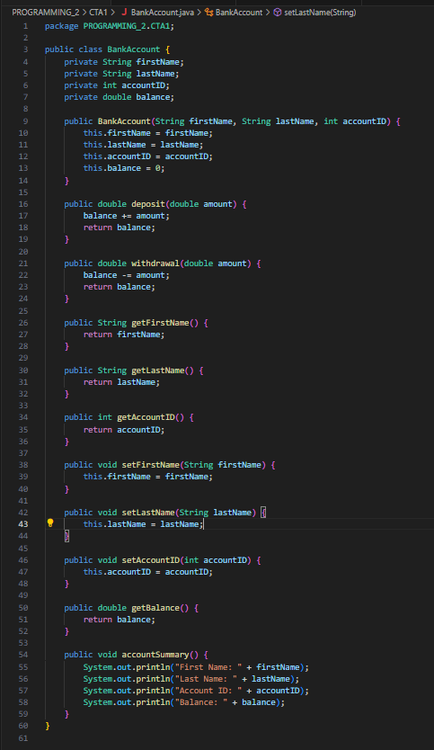

**CheckingAccount Class**

The *CheckingAccount* class inherits from the *BankAccount* superclass. The constructor shares the first name, last name, and account ID fields and adds an interest rate field. An overridden withdrawal method handles withdrawals that bring the account below zero, adding a $30 overdraft fee and sending a message to the user that the processing fee of $30 has been charged. Another method displays all account information from the account summary method of *BankAccount,* along with presenting the insurance rate. This method is called *displayAccount*. There is also a getter and setter for the interest rate, should it ever need to be changed and presented in the program.

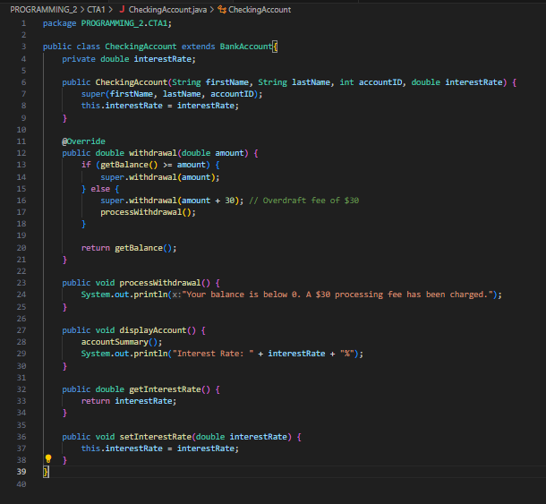

**TestBankAccount Class**

The *TestBankAccounts* class has an executable *main* method that creates an instance of *BankAccount* and *CheckingAccount* to test out calling their data and operations. This test class utilizes the deposit and withdrawal methods to change the balance of example objects in each class. It also demonstrates the functionality of the $30 overdraft fee. Aside from the deposit and withdrawal methods this class presents, it also tests the getters and setters of both classes.

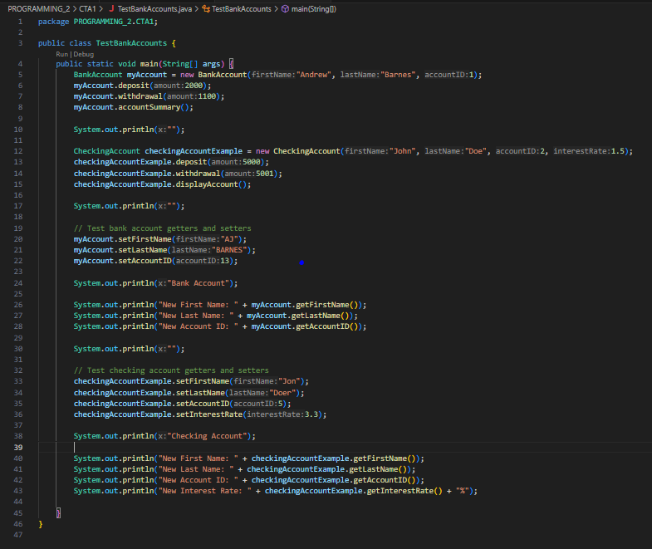

**Output**

